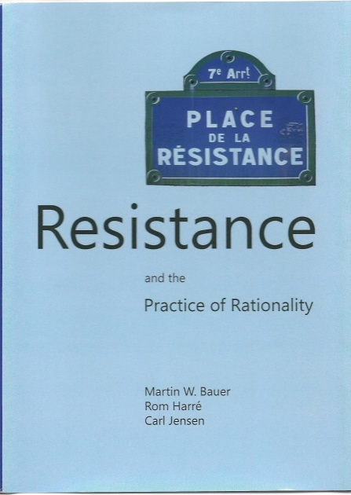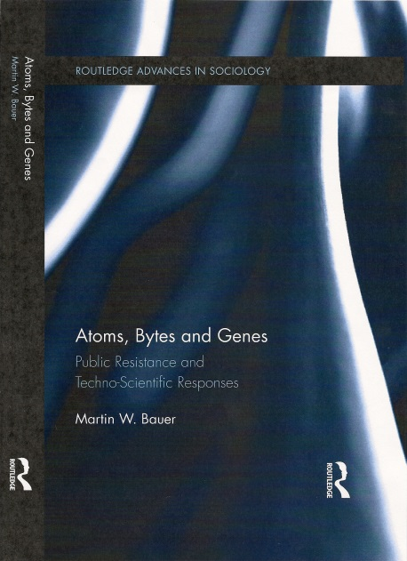

Learning from Resistance - Towards a Social Psychology of Strategic Technology Adaptation

Martin W Bauer

m.bauer@lse.ac.uk

Martin Bauer will discuss key ideas of his recent books ‘Resistance – and the Practice of Rationality and ‘Atoms, Bytes & Genes – public resistance and techno-scientific responses. Tarde (1890) famously argued that creativity and invention have no or little regularity, while the diffusion of ideas and practices follow the ’laws of imitation’. This idea remains influential as the third step in the linear model of innovation, as science translates into engineering and, eventually, marketing. Bauer argues that this model only applies when there is no resistance in the process which, however, is rare. More common are efforts of strategic mobilisation that encounter resistance at various stages, and this resistance is usefully modelled on a ‘pain analogy’: focussing attention where needed; enhancing the ‘bodily self-image’, evaluating on-going activities and urging strategic adaptation of the projects. Bauer illustrates this idea with observations on global developments of nuclear power since the 1980s, computing and IT since every, and of biotechnology in Brazil, US and Europe since the 1990s.

References
Bauer MW, P Pansegrau, and R Shukla (eds) (in press) The Cultural Authority of Science – Comparing across Europe, Asia, Africa and the Americas, London, Routledge Studies of Science, Technology & Society.
Bauer MW, S Gylstorff, EB Madsen, and N Mejlgaard (2018) The Fukushima Accident and Public Perceptions about Nuclear Power around the Globe – A Challenge & Response Model, Environmental Communication,
Bauer MW (2017) Resistance as a latent factor of innovation, in: Godin B and Vinck D (eds) Reflexive innovation. Alternative approaches to the pro-innovation bias, Cheltenham: Edward Elgar, pp. 159-81
Bauer M (2015). Atoms, Bytes & Genes: public resistance and techno-scientific responses. New York, Routledge.
Bauer MW (2013). New technology: a social psychology of disinhibition and restraint. In MW, Bauer, R Harre & C Jensen (eds) Resistance and the Practice of Rationality. Newcastle, Cambridge Scholars Publishers, pp79-100.
Bauer MW (2006). The paradoxes of resistance in Brazil. In Gaskell G & M Bauer (eds) Genomic & Society: legal, ethical and social dimension. London, Earthscan, p228-249
Bauer MW &G Gaskell (eds) (2002). Biotechnology – the making of a global controversy. Cambridge, CUP.
Bauer M (1995) Towards a functional analysis of resistance. In Bauer M (eds) Resistance to new technology. Cambridge, CUP, pp. 393-418.
Bauer M (1991) Resistance to change – a monitor of new technology. Systems Practice, 4,3, 181-196.
Tarde, G. (1962) [1890]. The Laws of Imitation. Gloucester, MA: Peter Smith.

Short CV:

Martin W Bauer read Psychology and Economic History (Bern, Zurich and London) and is Professor of Social Psychology and Research Methodology at the London School of Economics and elected Member of the German Academy of Technical Science (acatech). As a former Head or the LSE Methodology Department, Research Fellow of the Science Museum London, and editor of Public Understanding of Science (2009-2016), he currently directs the LSE’s MSc Social & Public Communication, and is a regular academic visitor to Brazil and China. He was a Member of an EC Committee to define indicators of RRI (Responsible Research & Innovation) and he advises national and international agencies (UK, Brazil, OECD, acatech) on measuring attitudes to science. He investigates science in common sense through theory building, comparative attitude, media monitoring and qualitative enquires. Publications include ‘The Cultural Authority of Science’ (in press, with Pansegrau & Shukla), ‘The Culture of Science’ (Routledge, 2012, with Shukla & Allum); ‘Journalism, Science & Society’ (Routledge, 2007; with Bucchi); ‘Biotechnology - the Making of a Global Controversy' (Cambridge, 2002; with Gaskell); and papers in Nature, Science, Nature-Biotechnology, Genetics & Society, PUS, STHV, SSS, IJPOR, SciComm and DIOGENE.

